**Return this completed form to: *(Insert institution’s name, address & telephone number)***

**Household Income Eligibility Statement – Child Care Institutions**

**Part 1 – Households Receiving Food Assistance Program (FAP), Family Independence Program (FIP), or Food Distribution Program on Indian Reservations (FDPIR) If any member of your household receives FAP, FIP, or FDPIR, provide the name and case number for the person who receives the benefits.**

**Name: Case Number:**

**Part 2 – Household Information How Often? (x) How Often? (x) How Often? (**x**)**

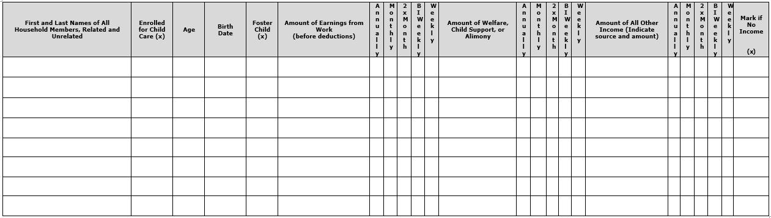

**Part 3 – All Households: Signature and Last Four (4) Digits of Adult Social Security Number** (Adult household member MUST sign and date)

I certify that all information on this form is true and that all income is reported. I understand that the center or day care home will receive federal funds based on the information I give. I understand that CACFP officials may verify the information. I understand that if I purposely give false information, the participant receiving meals may lose the meal benefits, and I may be prosecuted.

Signature: Print Name: Date: _

Last four digits of Social Security Number: XXX-XX-_ _ _ _ I do not have a Social Security Number

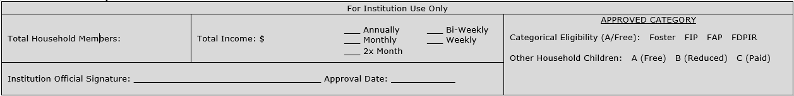**For Institution Use Only:**

**This form is valid for 12 months from the date of institution signature. Approval date and institution signature are required.**

# Privacy Act Statement

The Richard B. Russell National School Lunch Act requires the information on this application. You do not have to give the information, but if you do not, we cannot approve the participant for free or reduced-price meals. You must include the last four digits of the Social Security Number of the adult household member who signs the application. The Social Security Number is not required when you apply on behalf of a foster child or you list a Food Assistance Program (FAP), Family Independence Program (FIP), or Food Distribution Program on Indian Reservations (FDPIR) case number for the participant or other FDPIR identifier or when you indicate that the adult household member signing the application does not have a Social Security Number. We will use your information to determine if the participant is eligible for free or reduced-price meals, and for administration and enforcement of the Program.

**USDA Nondiscrimination Statement**

In accordance with federal civil rights law and U.S. Department of Agriculture (USDA) civil rights regulations and policies, this institution is prohibited from discriminating on the basis of race, color, national origin, sex (including gender identity and sexual orientation), disability, age, or reprisal or retaliation for

prior civil rights activity.

Program information may be made available in languages other than English. Persons with disabilities who require alternative means of communication to

obtain program information (e.g., Braille, large print, audiotape, American Sign Language), should contact the responsible state or local agency that

administers the program or USDA’s TARGET Center at (202) 720-2600 (voice and TTY) or contact USDA through the Federal Relay Service at (800) 877-8339.

To file a program discrimination complaint, a Complainant should complete a Form AD-3027, USDA Program Discrimination Complaint Form which can be

obtained online at: [USDA Program Discrimination Complaint Form](https://www.usda.gov/sites/default/files/documents/USDA-OASCR%20P-Complaint-Form-0508-0002-508-11-28-17Fax2Mail.pdf), from any USDA office, by calling (866) 632-9992, or by writing a letter addressed to USDA.

The letter must contain the complainant’s name, address, telephone number, and a written description of the alleged discriminatory action in sufficient detail

to inform the Assistant Secretary for Civil Rights (ASCR) about the nature and date of an alleged civil rights violation. The completed AD-3027 form or letter

must be submitted to USDA by: 1. **mail:** U.S. Department of Agriculture, Office of the Assistant Secretary for Civil Rights, 1400 Independence Avenue, SW, Washington, D.C. 20250-9410; or 2. **fax:** (833) 256-1665 or (202) 690-7442; or **email:** [program.intake@usda.gov](http://mailto:program.intake@usda.gov/)

This institution is an equal opportunity provider.

USDA Civil Rights Complaint Link:  
https://www.usda.gov/sites/default/files/documents/USDA-OASCR%20P-Complaint-Form-0508-0002-508-11-28-17Fax2Mail.pdf



Rev 7/2022